

**COMSATS University Islamabad (CUI)**

Software Requirement Specification  
(SRS DOCUMENT)

for

**BreathEX**

Version 1.0

***By***

**Student Name 1 CIIT/SP18-BCS-xxx/ISB**

**Student Name 2 CIIT/SP18-BCS-xxx/ISB**

***Supervisor*Supervisor Name**

***Co-Supervisor (if any)*Co-Supervisor Name**

*Bachelor of Science in Computer Science (20xx-20xx)*

Revision History

|  |  |  |  |
| --- | --- | --- | --- |
| **Name** | **Date** | **Reason for Changes** | **Version** |
|  |  |  |  |
|  |  |  |  |
|  |  |  |  |
|  |  |  |  |
|  |  |  |  |
|  |  |  |  |

Application Evaluation History

|  |  |
| --- | --- |
| **Comments (by committee)**  **\*include the ones given at scope time both in doc and presentation** | **Action Taken** |
|  |  |
|  |  |
|  |  |
|  |  |
|  |  |

Supervised by

Supervisor’s Name

Signature______________

**Table of Contents**

1. Introduction 1

1.1 Purpose 1

1.2 Scope 1

1.3 Modules 1

1.4 Overview 1

2. Overall Description 1

2.1 Product Perspective 1

2.2 User classes and characteristics 1

2.3 Operating Environment 1

2.4 Design and Implementation Constraints 2

3. Requirement Identifying Technique 2

4. Functional Requirements 2

4.1 Functional Requirement X 3

5. Non-Functional Requirements 3

5.1 Reliability 3

5.2 Usability 4

5.3 Performance 4

5.4 Security 4

6. External Interface Requirements 4

6.1 User Interfaces Requirements 4

6.2 Software interfaces 5

6.3 Hardware interfaces 5

6.4 Communications interfaces 5

7. References 5

# 

# Introduction

The introduction of the **Software Requirements Specification (SRS)** should provide an overview of the entire **SRS**. It should include the purpose, scope, modules and overview of the **SRS**.

## Purpose

The product that we are going to built is BreathEx, which will help the patient to detect many diseases like tuberculosis,covid, pneumonia by scanning x-rays of the patient using ML. There are various other functionalities in our application such as chatbot,infobox,reminder, virtual representation of lung model. This application will be helpful for both patient and doctor in order to manage patients record and help the doctor to cure the disease(tuberculosis, pneumonia, covid). Image processing and x-rays detection will be the prime focus of our work.

## Scope

The application would be designed to analyze chest X-rays to detect signs of TB, COVID-19, and pneumonia. The application would use machine learning algorithms, such as deep learning and computer vision, to accurately diagnose the diseases based on the features identified in the X-rays. The application would be trained on a large dataset of chest X-rays, annotated with ground truth labels, to increase its accuracy in detecting the diseases. The application could be integrated with existing healthcare systems to support healthcare professionals in making prompt and accurate diagnoses. The application would have an intuitive user interface for healthcare professionals to easily access and use the system. The application would generate reports that provide information on the diagnosis, including visualizations of the X-rays and the results of the analysis. The application would be validated using appropriate metrics, such as sensitivity, specificity, and accuracy, to ensure its accuracy in detecting TB, COVID-19, and pneumonia. The application would be deployed on appropriate platforms, such as mobile devices and desktop computers, to make it accessible to healthcare professionals globally. First of all user(patient) enter the system by login into the system. The  system will display list of all the diseases available in the system. After that user(patient) can select a disease to detect. Then system will display result of detection and display a report of disease with which user is suffering from. These reports will assist the doctors in proceeding the treatment of the patient. Then system will recommend medical suggestion to user for cure of disease for time being. User(patient) can also set alarms for taking medicine at specific time and days. The system can detect three major diseases which include covid 19 ,pneumonia, tuberculosis . Tuberculosis is detected with the analysis on x-rays which can achieved through ML by gathering datasets of different patients. The system is also capable of detecting COVID by analyzing X-rays of patients through ML. The system will give optimal result.

## Modules

List the product’s major modules, features or user capabilities, emphasizing those that distinguish it from previous or competing products. Give each module or feature a unique and persistent label to permit tracing it to other system elements.

## Overview

This subsection should describe what the rest of the **SRS** contains and explain how the document is organized.

# Overall Description

This section presents a high-level overview of the product and the environment in which it will be used, the anticipated users, and known constraints, assumptions, and dependencies.

## Product Perspective

Describe the product’s context and origin. Is it the next member of a growing product line, the next version of a mature system, a replacement for an existing application, or an entirely new product? Consider including visual models such as a context diagram to show the product’s relationship to other systems. See Appendix A for an example of context diagram.

## User classes and characteristics

Identify the various user classes that you anticipate will use this product, and describe their pertinent characteristics. See Appendix A for an example of how to present user classes and charateristics.

## Operating Environment

This section gives a precise description about the environment in which the software will operate:

OE-1:The BreathEx system shall operate correctly with the latest web browsers E.g.,Mozilla Firefox,Chrome.

OE-1:The BreathEx system shall operate with android device.

OE-1:The BreathEx system shall use mongodb database.

## Design and Implementation Constraints

There are times when a certain programming language must be used, a code library that has already had time invested to develop it needs to be used, and so forth. Describe any factors that will restrict the options available to the developers and the rationale for each constraint. Constraints are described further in Chapter 14[1], “Beyond functionality.”

Example:

*CON-1: The system shall use the current corporate standard Oracle database engine*

*CON-2: The mobile app frontend shall be built using Flutter.*

*CON-3: Online payments may be made only through PayPal.*

*CON-3: All textual data used by the application shall be stored in the form of XML files.*

# Requirement Identifying Technique

This section describes the requirements identifying technique(s) which further help to derive functional requirements specification. The selection of the technique(s) will depend on the type of project. For instance,

## Use Case Diagrams:

### Patient Usecase Diagram:

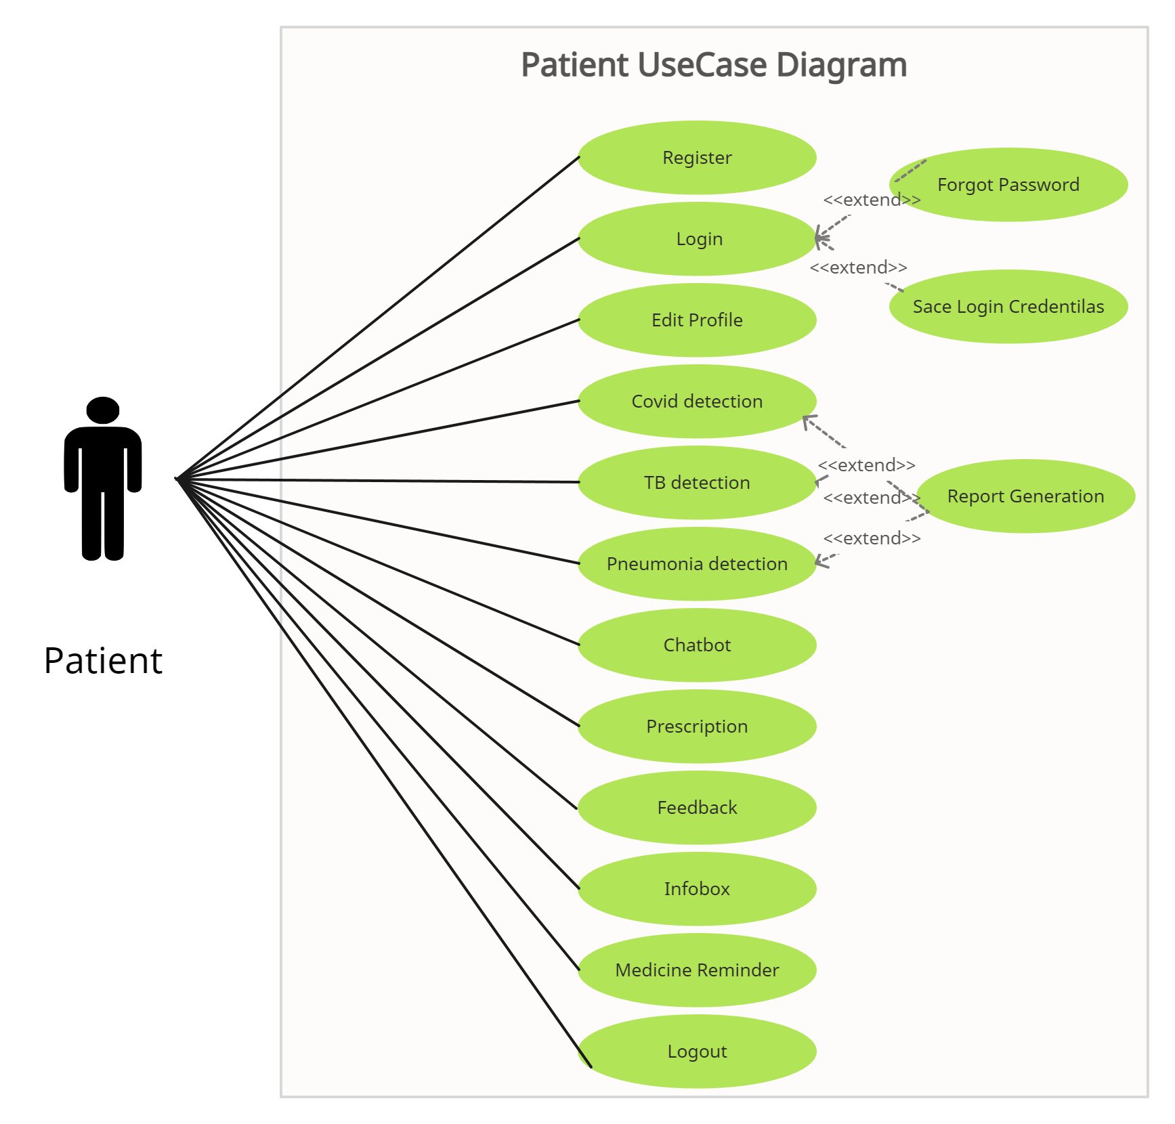

### 3.2.2 Admin Usecase Diagram:

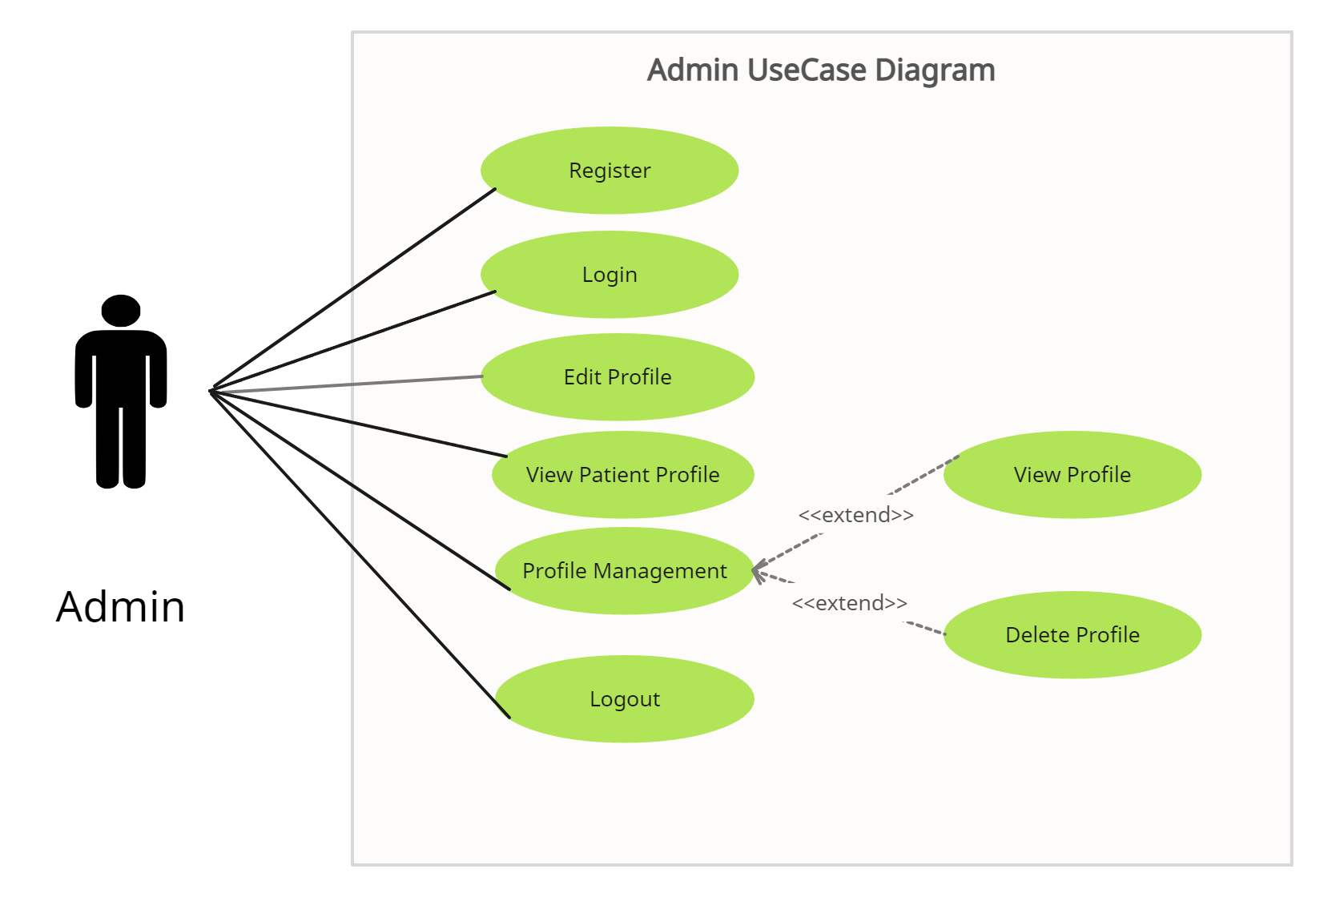

### Doctor Usecase Diagram:

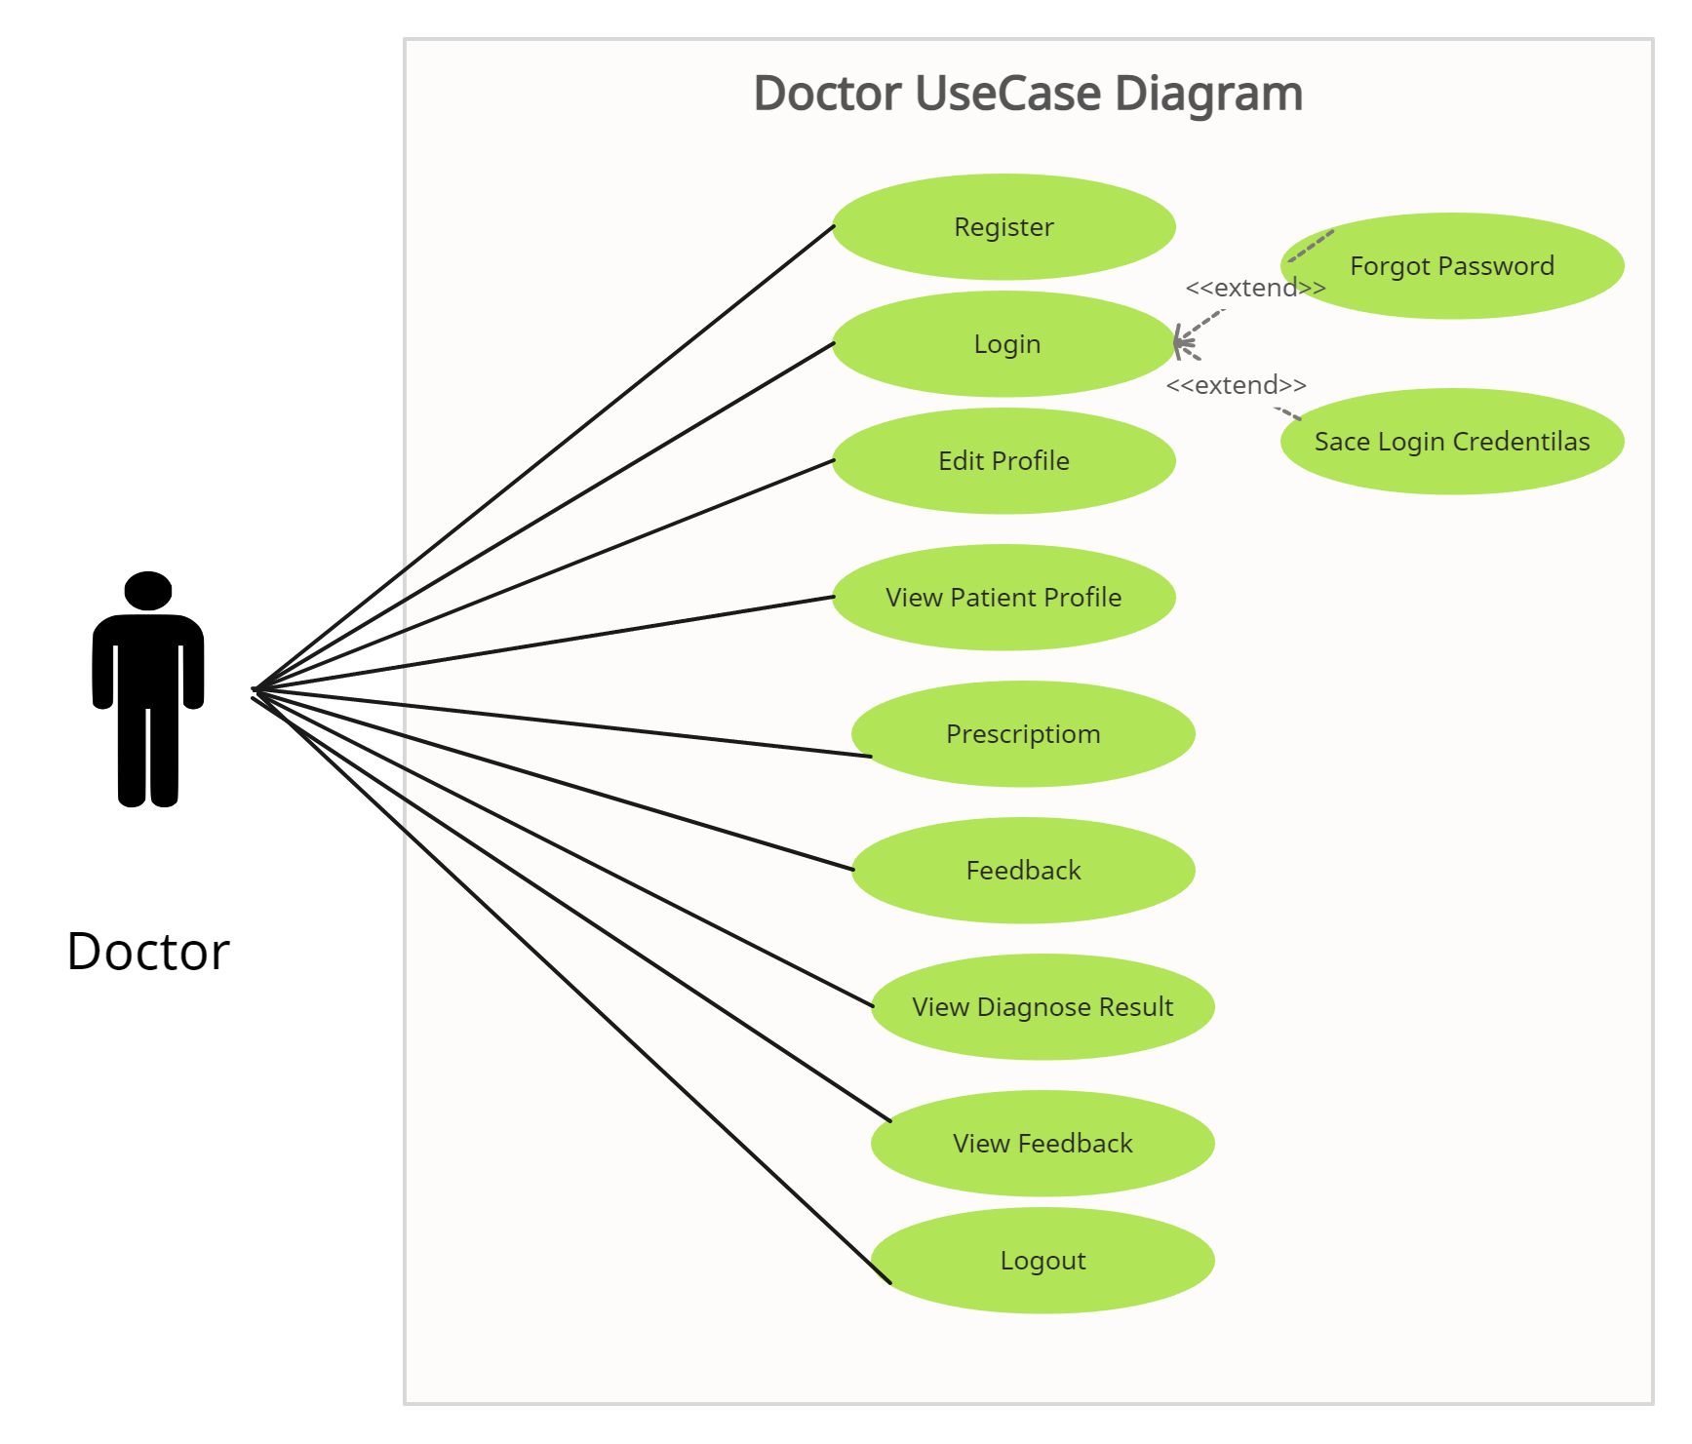

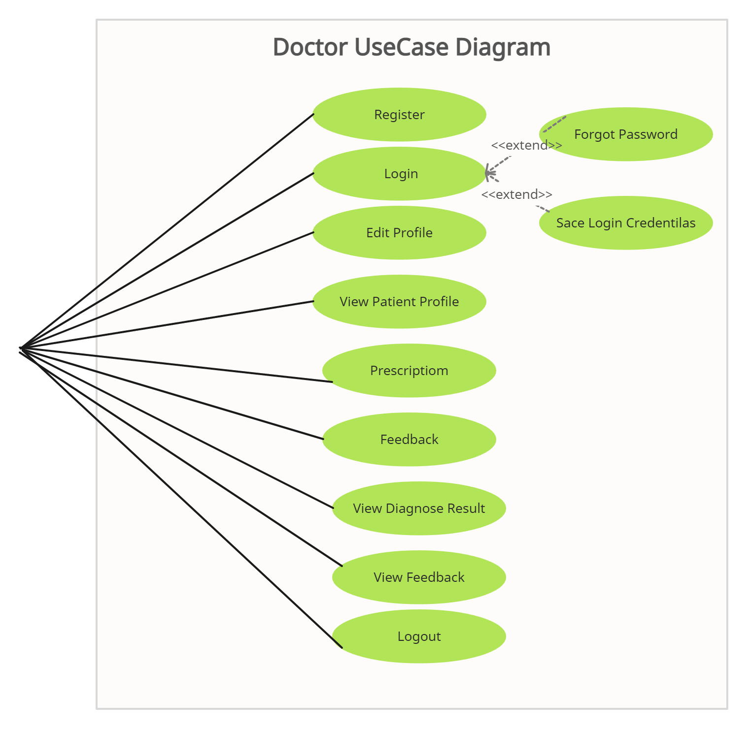

## Detailed Use case:

### Module 1: User Management:

This section gives detailed use cases that are common between Patient and Doctor

#### **3.1.1.1** Sign Up:

Table 3 SignUp Use Case

|  |  |
| --- | --- |
| **Use Case ID:** | UC-1.1 |
| **Use Case Name:** | SignUp |
| **Actors:** | Primary Actors: Patient, Doctors   |  |  |  |  | | --- | --- | --- | --- | |  |  |  |  | |
| **Description:** | Every patient and doctor must register themselves in order to create their account which will be used to identify them and store their specific data |
| **Trigger:** | Doctor will click on ‘Register Here’ option on application login page  Patient will click on ‘Register Here’ option on application login page |
| **Preconditions:** | PRE-1: Doctor/Patient must be on login page of application.  PRE-2:Doctor/Patient must have email acoount. |
| **Postconditions:** | POST-1. User request is sent to admin for acceptance of account creation. |
| **Normal Flow:** | 1.0 Signup  1. Doctor/Patient clicks on register here button  2. BreathEx displays option to signup as patient or doctor  3. Doctor clicks on ‘signup as doctor’ option (see 1.1)  2. BreathEx displays doctor registration form  3. Doctor/Patient fills the form  4. Doctor/Patient clicks on submit button (see 1.0 E1)  5. BreathEx sends confirmation email to the user  6. BreathEx displays form to enter confirmation code  7. Doctor/Patient enters confirmation code and then clicks on submit button (see 1.0 E2)  8. BreathEx stores details of the new user and forwards the request of account creation to admin  9. BreathEx displays “account creation request sent to admin” message on screen for 2 seconds and then redirects user to the login page  10. User notifies user via email that he/she have to wait for admin’s approval |
| **Alternative Flows:** | 1.1 Patient clicks on ‘sign up as patient’ option  1. BreathEx displays patient registration form  2. Return to step 3 of normal flow. |
| **Exceptions:** | 1.0. E1 Doctor/Patient enters invalid data. System informs Doctor/Patient that that data entered in specific fields is invalid  2a. If Doctor/Patient re-enters valid data and submits, then system continues to step 5 of normal flow  2b. Else if Doctor/Patient does not enter valid data, then system keeps displaying invalid data message and stays on the form.  1.0. E2 Doctor/Patient takes longer that 3 minutes to submit correct confirmation code.  1. System informs user that time limit to enter confirmatioin code has expired and enables resend code button.  2a. If Doctor/Patient clicks on resend button, System resends confirmation code to user’s email and returns to step 6 of normal flow.  2b. Else if Doctor/Patient clicks on go back button, System takes user back to the registration form. |
| **Business Rules** | BR-1: The Doctor/Patient must have an account to perform any action over the application.  BR-2: Every Doctor/Patient has unique ID  BR-3: System shall check for special password conditions during registration.  BR-4: Doctor/Patient can only have one account at a time. |
| **Assumptions:** |  |

### 3.1.1.2: Login

Table 4: Login Use Case

|  |  |
| --- | --- |
| **Use Case ID:** | UC-1.2 |
| **Use Case Name:** | Login |
| **Actors:** | Primary Actors: Doctor, Patient |
| **Description:** | Doctor/Patient will login the account by providing their credentials |
| **Trigger:** | Doctor/Patient presses login button |
| **Preconditions:** | PRE-1. Doctor/Patient is registered on the system. |
| **Postconditions:** | POST-1. Doctor/Patient logs in to the system. |
| **Normal Flow:** | 1. Doctor/Patient enters the credentials. (see 1.1) 2. Doctor/Patient clicks on login button. (see 1.0 E.1) 3. Doctor/Patient is logged in to the system. |
| **Alternative Flows:** | 1.1. If user forgets the login credentials,  1. Doctor/Patient clicks on forgot password or username  2. System asks Doctor/Patient for the desired email on which he has registered the account.  3. System confirms the email and sends ‘Forget Password’ notification on the desired email.  4. Doctor/Patient change the password.  5. Use case resumes on step 1 of normal flow. |
| **Exceptions:** | 1. E.1 If the Doctor/Patient enters invalid credentials   2a. System will prompt Doctor/Patient to enter correct credentials  2b. User re-writes the correct information.  2c. Use case resumes on step 2 of normal flow |
| **Business Rules** | BR-1  BR-9 |
| **Assumptions:** |  |

#### 3.1.1.3 Logout

Table 5: Log Out Use Case

|  |  |
| --- | --- |
| **Use Case ID:** | UC-1.3 |
| **Use Case Name:** | Log Out |
| **Actors:** | Primary Actors: Doctor, Patient |
| **Description:** | Doctor/Patient will be able to logout from his/her account. |
| **Trigger:** | Doctor/Patient selects Logout option. |
| **Preconditions:** | PRE-1. Doctor/Patient is logged in to the system. |
| **Postconditions:** | POST-1. Changes are saved  POST-2. Doctor/Patient is logged out from the system. |
| **Normal Flow:** | 1. Doctor/Patient clicks on logout option. (see 1.0 E.1) 2. Confirm logout dialogue box appears. (see 1.1) 3. Doctor/Patient click on ‘Ok’ option. 4. Changes are saved and user is logged out from their account. |
| **Alternative Flows:** | 1. If Doctor/Patient clicks on ‘No’ option    1. System stays on the last accessed page until user chooses another option. 2. If Doctor/Patient clicks on Ok button again:    * 1. Use case resumes on step 4 of normal flow |
| **Exceptions:** | * 1. E.1 Doctor/Patient tries to logout with pending information   2a. Takes user to the page with pending information   * 1. E.2 If no more information pending, normal flow starts from step1 |
| **Business Rules** | ----- |

#### View Profile

Table 6: View Profile Use Case

|  |  |
| --- | --- |
| **Use Case ID:** | UC-1.4 |
| **Use Case Name:** | View Profile |
| **Actors:** | Primary actors: Doctor, Patient |
| **Description:** | Registered doctors/students can login to their individual accounts and view their profile information by using the view profile option |
| **Trigger:** | User clicks on view profile option |
| **Preconditions:** | PRE-1. Doctor/Patient is logged in BreathEx system  PRE-2. Doctor/Patient is on the main menu page |
| **Postconditions:** | POST-1. BreathEx system displays user information |
| **Normal Flow:** | 1.0 View Profile  1. BreathEx system displays menu of options  2. Doctor/Patient selects View Profile option  3. BreathE system displays Doctor’s/Patient’s profile information |
| **Alternative Flows:** | ---- |
| **Exceptions:** | ----- |
| **Business Rules (if required)** | BR-1 |

#### Edit Profile

Table 7: Edit Profile Use Case

|  |  |
| --- | --- |
| **Use Case ID:** | UC-1.5 |
| **Use Case Name:** | Edit Profile |
| **Actors:** | |  |  |  | | --- | --- | --- | | Primary Actor: | Doctor, Patient |  | |
| **Description:** | The doctor/patient logs into his/her account and clicks on the view profile option and then on the edit profile button to edit their profile. |
| **Trigger:** | The doctor/patient clicks on edit profile button. |
| **Preconditions:** | PRE-1. Doctor/Patient is logged into their account. |
| **Postconditions:** | POST-1. Changes in the doctor/patient profile are saved. |
| **Normal Flow:** | 1.0 Edit profile and save changes   1. Doctor/Patient clicks on edit profile button. 2. Doctor/Patient’s profile information will be displayed where all the fields will be editable. 3. Doctor/Patient makes changes. 4. Doctor/Patient clicks on save changes button.(see 1.0.E1) 5. Confirm changes dialogue box appears. 6. Doctor/Patient clicks on yes option.(see.1.1) 7. The system saves the changes and a profile updated message is displayed. |
| **Alternative Flows:** | 1.1 Edit profile and don’t save changes  1. Doctor/Patient edits profile but clicks on No when confirm changes dialogue box appears.  2. Return to step 2 of normal flow. |
| **Exceptions:** | 1. E1 Doctor/Patient enters invalid information and clicks on submit. 2. Invalid credentials please enter again dialogue box will be displayed. 3. Doctor/Patient enters valid information and clicks on submit button. 4. Resume form step 5 of normal flow. |
| **Business Rules** | BR-1 |
| **Assumptions:** | ---- |

#### Delete Account

Table 8: Delete Account Use Case

|  |  |
| --- | --- |
| **Use Case ID:** | UC-1.6 |
| **Use Case Name:** | Delete Account |
| **Actors:** | |  |  |  | | --- | --- | --- | | Primary Actor: | Doctor, Patient |  | |
| **Description:** | The doctor/patient logs into his/her account and clicks on the delete account button to permanently delete their account. |
| **Trigger:** | The doctor/patient clicks on the delete account button. |
| **Preconditions:** | PRE-2. Doctor/Patient has an existing registered account.  PRE-1. Doctor/Patient is logged into their account. |
| **Postconditions:** | POST-1. Doctor/Pateint‘s account and information will be deleted from the database.  POST-2. Doctor/Patient will be redirected to the home page of the application. |
| **Normal Flow:** | * 1. Delete Account   1.Doctor/Patient clicks on delete account option from the given menu.   1. The system asks Doctor/Patient to enter account password.(see 1.0 E2) 2. The system verifies the password. 3. Message is displayed to the Doctor/Patient that once the account is deleted, all related data of user will be permanently deleted and they will not be able to recover it. 4. Doctor/Patient selects proceed with deletion option.(see 1.1) 5. Confirm deletion dialogue box appears. 6. Doctor/Patient clicks on ok button.(see 1.2) 7. Doctor/Patient account including all relevant information is deleted from the database.(see 1.0.E1) 8. Doctor/Patient is redirected to the home page of the application. |
| **Alternative Flows:** | * 1. In step 5 of normal flow Doctor/Patient clicks on Back option:  1. Doctor/Student is redirected to his/her home page.    1. In step 7 of normal flow doctor/patient clicks on cancel button: 2. Doctor/Patient is redirected to his/her home page. |
| **Exceptions:** | 1.0. E1 Doctor/Patient closes the application during the process of deletion:   1. No changes will be saved as account deletion is unsuccessful.   1.0 E2 In step 2 of normal flow the Doctor/Patient enters incorrect password.   1. System fails to verify the password. 2. System displays a message of wrong password. 3. Use case resumes from step 2 of normal flow. |
| **Business Rules** | BR-1, BR-6 |

#### Recover Account

Table 9: Recover Account Use Case

|  |  |
| --- | --- |
| **Use Case ID:** | UC-1.7 |
| **Use Case Name:** | Recover Account |
| **Actors:** | Primary Actors: Doctor, Patient |
| **Description:** | If a doctor or patient forgets their account password, he/she will be able to recover it by following some instructions and fulfilling some requirements asked by the system |
| **Trigger:** | User clicks on recover account option |
| **Preconditions:** | PRE-1. Doctor/Patient is an account holder in the system |
| **Postconditions:** | POST-1. System sends recovery password to Doctor/Patient  POST-2. BreathEx database is updated with new password of recovered account |
| **Normal Flow:** | 1. Recover Account   1. Doctor/Patient clicks on recover account option  2. BreathEx displays form for user to enter recovery email (see 1.1)  3. Doctor/User enters recovery email  4. Doctor/Patient enters submit button (see 1.0 E1)  5. BreathEx sends new password to the recovery email  6. BreathEx displays form to enter recovery code (see 1.0 E2) (see 1.1)  7. Doctor/Patient enters recovery code  8. Doctor/Student enters submit button (see 1.0 E2)  9. BreathEx displays form to enter new password and confirm password (see 1.0 E3) (see 1.1)  10. Doctor/Patient fills form and clicks on submit button  11. BreathEx updates the database with user’s new password and displays account  recovered message on screen  12. BreathEx takes Doctor/Student to the login page |
| **Alternative Flows:** | 1.1 Doctor/Patient clicks on cancel recovery process option  1. BraethEx takes Doctor/Patient back to the login page |
| **Exceptions:** | 1.0. E1 Recovery email entered by Doctor/Patient does not match with any user emails in the database  1. BreathEx informs Doctor/Patient that he/she has entered wrong email address.  2a. If Doctor/Patient enters correct email, then BraethEx continues to step 4 of normal flow.  2b. Else if Doctor/Patient enters wrong recovery email thrice, BraethEx takes Doctor/Student back to login page.  1.1. E2 Doctor/Patient takes longer that 3 minutes to submit correct recovery code.  1. BreathEX informs Doctor/Patient that time limit to enter recovery code has expired and enables resend recovery code button.  2a. If Doctor/Patient clicks on resend button, BreathEx resends recovery code to Doctor’s/Patient’s email and restarts from step 5 of normal flow.  2b. Else if Doctor/Patient clicks on go back button, BreathEx takes Doctor/Patient back to the login page.   * 1. E3 New password and confirm password don’t match   1. BraethEx informs Doctor/Patient that passwords do not match and waits for Doctor/Patient to re-enter matching passwords  2a If Doctor/Patient enters matching passwords, BraethEx continues to step 10 of normal flow  2b Else if passwords do not match , BreathEx keeps repeating step 8 of normal flow until matching passwords are entered |
| **Business Rules** | BR-1, BR-8, BR-10 |
| **Assumptions:** |  |

#### View Doctors

|  |  |
| --- | --- |
| **Use Case ID:** | UC-1.8 |
| **Use Case Name:** | View Doctors |
| **Actors:** | Primary Actors: Patient |
| **Description:** | Patient logs into his/her account, clicks on the instructor option and views the list of doctors |
| **Trigger:** | Patient clicks on doctor option from the dashboard |
| **Pre-conditions:** | PRE-1. Patient is logged in  PRE-2. Patient has clicked the doctor option |
| **Post-conditions:** | POST-1 System displays list of doctors to the patient |
| **Normal Flow:** | * 1. View Doctors   1. Patient clicks on the doctor option  2. The system displays the names of the doctors in alphabetical order inside a small rectangle.  3. Patient selects the instructor whose information he/she wants to view.(see 1.2)  4. The system displays the detailed information of the doctors |
| **Alternative Flows:** | 1.2 In step 3 of normal flow instead of browsing through the given list of doctors the patient searches the doctor using his/her name or id  1. The patient enters the name or id of the instructor whose information he/she needs  2. The system displays the name of the doctor inside a small box.  (see 1.0 E1)  3. The patient selects the searched instructor from the search result  4. Use case resumes from the step 3 of normal flow. |
| **Exceptions:** | 1.0 E1 In step 2 of alternate flow the searched name is not found:   1. The system displays the message of doctor not found. 2. The patient removes the name from the search bar. 3. Use case resumes from step 2 of normal flow. |
| **Business Rules** | BR-1, BR-2, BR-4, BR-6 |
| **Assumptions:** |  |

#### View Patients

|  |  |
| --- | --- |
| **Use Case ID:** | UC-1.9 |
| **Use Case Name:** | View Patients |
| **Actors:** | Primary Actors: Doctor |
| **Description:** | Doctor logs into his/her account, clicks on the patient option and views the list of patients |
| **Trigger:** | Doctor clicks on student option from the dashboard |
| **Pre-conditions:** | PRE-1. Doctor is logged in  PRE-2. Doctor has clicked the patient option |
| **Post-conditions:** | System displays list of patients to the doctor |
| **Normal Flow:** | * 1. View Patients   1. Doctor clicks on the patient option  2. The system displays the names of the patients in alphabetical order inside a small rectangle.  3. Doctor selects the patient whose information he/she wants to view.(see 1.1)  4. The system displays the detailed information of the patient |
| **Alternative Flows:** | 1.2 In step 3 of normal flow instead of browsing through the given list of patients the doctor searches the student using his/her name or registration number  1. The doctor enters the name or registration number of the patient whose information he/she needs  2. The system displays the name of the patient inside a small box (see 1.0 E1)  3. The doctor selects the searched student from the search result  4. Use case resumes from the step 3 of normal flow. |
| **Exceptions:** | 1. E1 In step 2 of alternate flow the searched name is not found:   1. The system displays the message of patient not found.  2. The doctor removes the name from the search bar.  3. Use case resumes from step 2 of normal flow. |
| **Business Rules** |  |
| **Assumptions:** |  |

#### Disease Detection

|  |  |
| --- | --- |
| **Use Case ID:** | UC-1.10 |
| **Use Case Name:** | Disease Detection |
| **Actors:** | Primary Actors: Patient |
| **Description:** | Patient login to his/her account, clicks on the disease detection option and view list of diseases available in the system to detect disease with he/she is suffering from. |
| **Trigger:** | Patient clicks on the disease detection option from dashboard |
| **Pre-conditions:** | PRE-1. Patient is logged in  PRE-2. Patient has clicked the disease detection option |
| **Post-conditions:** | System displays list of disease available in the system to patient |
| **Normal Flow:** | 1. Patients clicks on the disease detection option  2. The system displays the names of disease in alphabetical order inside a small box.  3. Patient select disease which he/she want to detect.  4. The system displays the result of detection and send one copy to patient and one copy to doctor. |
| **Alternative Flows:** | 1.2  1.  2.  3.  4. |
| **Exceptions:** | 1. E1 In step 3 of normal flow the searched disease is not found:   1. The system displays the message of disease not found.  2. The patient removes the name from the search bar.  3. Use case resumes from step 2 of normal flow. |
| **Business Rules** | BR-1: The patient must have registered to perform any action.  BR-2: Each patient has unique patient_id and password.  BR-3: Patient should check special password condition during registration.  BR-4: Patient can have only one account at a time. |
| **Assumptions:** |  |

#### COVID Dectction

|  |  |
| --- | --- |
| **Use Case ID:** | UC-1.11 |
| **Use Case Name:** | COVID Detction |
| **Actors:** | Primary Actors: Patient |
| **Description:** | Patient login to his/her account, clicks on the COVID detection option from list of available diseases in the system to detect COVID. |
| **Trigger:** | Patient clicks on the COVID detection option from disease detection option from dashboard |
| **Pre-conditions:** | PRE-1. Patient is logged in  PRE-2. Patient has clicked the COVID detection option |
| **Post-conditions:** | System displays result of COVID detection results and send one copy to patient and one copy to doctor |
| **Normal Flow:** | 1. Patients clicks on the COVID detection option  2. The system displays result of detection along with report and send one copy of report to doctor. |
| **Alternative Flows:** | 1.2 In step 1 of normal flow if the patient selects other disease detection option other than COVID.  1. Patient is logged in the system by providing his/her credentials.  2. Patient clicks on disease detection option from dashboard.  3. Patient clicks on desease detection other COVID detection option.  4. System will displays the result of other disease detection result along with report and send one copy to doctor other than COVID |
| **Exceptions:** | 1. E1 In step 3 of normal flow the searched disease is not found:   1. The system displays the message of disease not found.  2. The patient removes the name from the search bar.  3. Use case resumes from step 2 of normal flow. |
| **Business Rules** | BR-1: The patient must have registered to perform any action.  BR-2: Each patient has unique patient_id and password.  BR-3: Patient should check special password condition during registration.  BR-4: Patient can have only one account at a time. |
| **Assumptions:** |  |

# Functional Requirements

This section describes the functional requirements of the system expressed in the natural language style. This section is typically organized by feature as a system feature name and specific functional requirements associated with this feature. It is just one possible way to arrange them. Other organizational options include arranging functional requirements by use case, process flow, mode of operation, user class, stimulus, and response depend on what kind of technique has been used to understand functional requirements. Hierarchical combinations of these elements are also possible, such as use cases within user classes. For further detail see Chapter 10 “Documenting the requirements”. Let consider the feature scheme as an example.

## Functional Requirement X

Itemize the specific functional requirements associated with each feature. These are the software capabilities that must be implemented for the user to carry out the feature’s services or to perform a use case. Describe how the product should respond to anticipated error conditions and to invalid inputs and actions. Uniquely label each functional requirement, as described earlier. You can create multiple attributes for each functional requirement, such as rationale, source, dependencies, etc. The following template is required to write functional requirements. For further detail see Chapter 11” Writing excellent requirements”.

Table 1: Description of FR-1

|  |  |
| --- | --- |
| **Identifier** | FR-1 |
| **Title** | Title of requirement |
| **Requirement** | Description of requirement which may be written either from the user or system perspective e.g.  If written in a **user perspective**  The [user class or actor name] shall be able to [do something] [to some object] [qualifying conditions, response time, or quality statement].  If written in a **system perspective**  [optional precondition] [optional trigger event] the system shall [expected system response] |
| **Source** | Where this requirement comes from (who originate it) |
| **Rationale** | The motivation behind the requirement |
| **Business Rule (if required)** | Any restriction, policy, the rule that the particular requirement must be fulfilled through its functional behavior |
| **Dependencies** | Requirements ID that is dependent on this requirement |
| **Priority** | High/Medium/Low |

# Non-Functional Requirements

This section specifies nonfunctional requirements other than constraints, which are recorded in section 2.3, and external interface requirements, which will appear in section 7. These quality requirements should be specific, quantitative, and verifiable. Chapter 14 “beyond functionality” presents more information about these quality attribute requirements and many examples. The following are some examples of documenting guidelines.

## Reliability

Requirements about how often the software fails. The measurement is often expressed in MTBF (mean time between failures). The definition of a failure must be clear. Also, don't confuse reliability with availability which is quite a different kind of requirement.  Be sure to specify the consequences of software failure, how to protect from failure, a strategy for error detection, and a strategy for correction.

## Usability

Usability requirements deal with ease of learning, ease of use, error avoidance and recovery, the efficiency of interactions, and accessibility. The usability requirements specified here will help the user interface designer create the optimum user experience.

Example:

*USE-1: The COS shall allow a user to retrieve the previous meal ordered with a single interaction.*

## 

## Performance

State specific performance requirements for various system operations. If different functional requirements or features have different performance requirements, it’s appropriate to specify those performance goals right with the corresponding functional requirements, rather than collecting them in this section.

Example:

*PER-1: 95% of webpages generated by the COS shall download completely within 4 seconds from the time the user requests the page over a 20 Mbps or faster Internet connection.*

## Security

One or more requirements about protection of your system and its data. The measurement can be expressed in a variety of ways (effort, skill level, time, ...) to break into the system.  Do not discuss solutions (e.g. passwords) in a requirements document.

# External Interface Requirements

This section provides information to ensure that the system will communicate properly with users and with external hardware or software elements. A complex system with multiple subcomponents should create a separate interface specification or system architecture specification. The interface documentation could incorporate material from other documents by reference. For instance, it could point to a hardware device manual that lists the error codes that the device could send to the software.

## User Interfaces Requirements

Describe the logical characteristics of each user interface that the system needs. Some possible items to include are

* References to GUI standards or product family style guides that are to be followed.
* Standards for fonts, icons, button labels, images, color schemes, field tabbing sequences, commonly used controls, and the like.
* Screen layout or resolution constraints.
* Standard buttons, functions, or navigation links that will appear on every screen, such as a help button.
* Shortcut keys.
* Message display conventions.
* Layout standards to facilitate software localization.
* Accommodations for visually impaired users.

Document the user interface design details, such as specific dialog box layouts, in a separate user interface specification, not in the SRS. Including screen mock-ups in the SRS to communicate another view of the requirements is helpful but make it clear that the mock-ups are not the committed screen designs. If the SRS is specifying an enhancement to an existing system, it sometimes makes sense to include screen displays exactly as they are to be implemented. The developers are already constrained by the current reality of the existing system, so it's possible to know up front just what the modified, and perhaps the new, screens should look like.

## Software interfaces

Describe the connections between this product and other software components (identified by name and version), including other applications, databases, operating systems, tools, libraries, websites, and integrated commercial components (If any).

Example:

SI-1: Cafeteria Inventory System

*SI-1.1: The COS shall transmit the quantities of food items ordered to the Cafeteria Inventory System through a programmatic interface*.

## Hardware interfaces

Describe the characteristics of each interface between the software components and hardware components, if any, of the system. This description might include the supported device types, the data and control interactions between the software and the hardware, and the communication protocols to be used. For more about specifying requirements for systems containing hardware, see Chapter 26, “Embedded and other real-time systems projects.”

## Communications interfaces

CI-1: The system shall send an confirmation email to Doctor and Patient about their registration process.

CI-2: The system shall send a notification to patient when doctor send the prescription.

CI-3: The system shall supports all types of web browsers.

CI-4: The system uses simple electronic forms for requirements such as registration.

# References

List any documents or other resources to which this SRS refers, if any. These might include user interface style guides, standards, system requirements specifications, interface specifications, or the SRS for a related product. The following are a few examples of different resources i.e. journal article, book, and website.

* 1. Lyda M.S. Lau, Jayne Curson, Richard Drew, Peter Dew and Christine Leigh, (1999), Use Of VSP Resource Rooms to Support Group Work in a Learning Environment, ACM 99, pp-2. **(Journal paper example)**
  2. Hideyuki Nakanishi, Chikara Yoshida, Toshikazu Nishmora and TuruIshada, (1996), FreeWalk: Supporting Casual Meetings in a Network, pp 308-314 **(paper on web)** http://www.acm.org/pubs/articles/proceedings/cscw/240080/p308-nakanishi.pdf
  3. Ali Behforooz& Frederick J.Hudson, (1996), Software Engineering Fundamentals, Oxford University Press. Chapter 8, pp255-235. **(book reference example)**
  4. Page Author, Page Title, http://www.bt.com/bttj/archive.htm, Last date accessed**. (web site)**

**Appendix A**

**Example: Context Diagram**

The Cafeteria Ordering System is a new software system that replaces the current manual and telephone processes for ordering and picking up meals in the Process Impact cafeteria. The context diagram in Figure 1 illustrates the external entities and system interfaces.

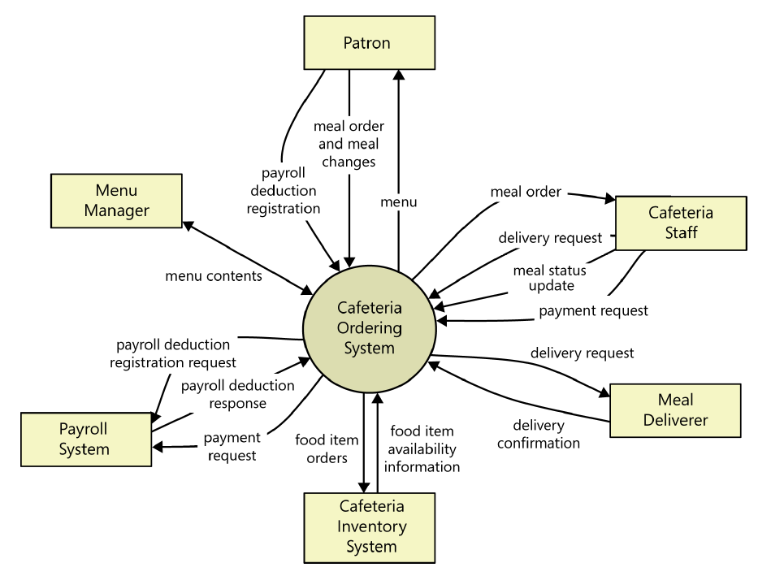

Figure 1: Context diagram of the Cafeteria Ordering System.

**Example: User Classes and Characteristics**

Table 1 Shows user classes and characteristic for BreathEx

|  |  |
| --- | --- |
| **User class** | **Description** |
| **Patient** | A patient is a person whoo can check if he/she is suffering from COVID,TB or Pnuemonia by viwing the result of detection.;Patient can also set medicine reminder to take medicines at specified intervals.Patient can detect COVID,TB and pneumonia by using this application.Patient can view the prescription which he receives from doctor.Patient must upload his x-ray report and images in order to detect disease.Patient can also give feedback about application like if he/she is satisfied with the application and provide rating. Doctor can also view diagnose result. |
| **Doctor** | Doctor job is to edit patient profile and view patient profile.Doctor can also write prescription corresponding to patient report which he receives when detect any disease. Doctor can also provide feedback about application like if he/she is satisfied with the application and provide rating. Doctor can also view diagnose result. |
| **Admin** | Admin’s job is to verifying and managing requests from the doctors and students for their account creation. The admin will also be responsible for his profile management like view and delete profile.The admin have also access to view patient profile like no of pstients his medical history etc. |

**Example: Use case Diagram**

Following use case diagram is of an appointment system in which all the use case diagram relationships are presented. In further in **Table 2** to the detail of use case diagram sytax is provided.

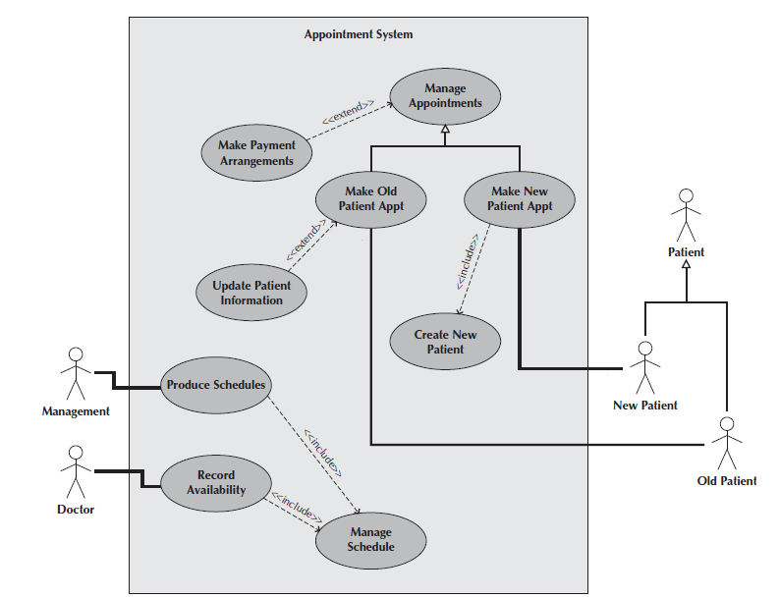

Figure 2: Use Case Diagram of an Appointment System

**Syntax for Use case Diagram**

Table 2 Syntax for Use case Diagram

|  |  |
| --- | --- |
| **An actor:**  ■ Is a person or system that derives benefit from and is external to the subject.  ■ Is depicted as either a stick figure (default) or, if a nonhuman actor is involved, a  rectangle with <<actor>> in it (alternative).  ■ Is labeled with its role.  ■ Can be associated with other actors using a specialization/superclass association,  denoted by an arrow with a hollow arrowhead.  ■ Is placed outside the subject boundary. |  |
| **A use case:**  ■ Represents a major piece of system functionality.  ■ Can extend another use case.  ■ Can include another use case.  ■ Is placed inside the system boundary.  ■ Is labeled with a descriptive verb–noun phrase. |  |
| **subject boundary:**  ■ Includes the name of the subject inside or on top.  ■ Represents the scope of the subject, e.g., a system or an individual  business process. |  |
| **An association relationship:**  ■ Links an actor with the use case(s) with which it interacts. |  |
| **An include relationship:**  ■ Represents the inclusion of the functionality of one use case within another.  ■ Has an arrow drawn from the base use case to the used use case. |  |
| **An extend relationship:**  ■ Represents the extension of the use case to include optional behavior.  ■ Has an arrow drawn from the extension use case to the base use case. |  |
| **A generalization relationship:**  ■ Represents a specialized use case to a more generalized one.  ■ Has an arrow drawn from the specialized use case to the base use case. |  |

**Detail Use Case Example**

Table 3 SignUp Use Case

|  |  |
| --- | --- |
| **Use Case ID:** | UC-1.1 |
| **Use Case Name:** | SignUp |
| **Actors:** | Primary Actors: Patient, Doctors   |  |  |  |  | | --- | --- | --- | --- | |  |  |  |  | |
| **Description:** | Every patient and doctor must register themselves in order to create their account which will be used to identify them and store their specific data |
| **Trigger:** | Doctor will click on ‘Register Here’ option on application login page  Patient will click on ‘Register Here’ option on application login page |
| **Preconditions:** | PRE-1: Doctor/Patient must be on login page of application.  PRE-2:Doctor/Patient must have email acoount. |
| **Postconditions:** | POST-1. User request is sent to admin for acceptance of account creation. |
| **Normal Flow:** | 1.0 Signup  1. Doctor/Patient clicks on register here button  2. BreathEx displays option to signup as patient or doctor  3. Doctor clicks on ‘signup as doctor’ option (see 1.1)  2. BreathEx displays doctor registration form  3. Doctor/Patient fills the form  4. Doctor/Patient clicks on submit button (see 1.0 E1)  5. BreathEx sends confirmation email to the user  6. BreathEx displays form to enter confirmation code  7. Doctor/Patient enters confirmation code and then clicks on submit button (see 1.0 E2)  8. BreathEx stores details of the new user and forwards the request of account creation to admin  9. BreathEx displays “account creation request sent to admin” message on screen for 2 seconds and then redirects user to the login page  10. User notifies user via email that he/she have to wait for admin’s approval |
| **Alternative Flows:** | 1.1 Patient clicks on ‘sign up as patient’ option  1. BreathEx displays patient registration form  2. Return to step 3 of normal flow. |
| **Exceptions:** | 1.0. E1 Doctor/Patient enters invalid data. System informs Doctor/Patient that that data entered in specific fields is invalid  2a. If Doctor/Patient re-enters valid data and submits, then system continues to step 5 of normal flow  2b. Else if Doctor/Patient does not enter valid data, then system keeps displaying invalid data message and stays on the form.  1.0. E2 Doctor/Patient takes longer that 3 minutes to submit correct confirmation code.  1. System informs user that time limit to enter confirmatioin code has expired and enables resend code button.  2a. If Doctor/Patient clicks on resend button, System resends confirmation code to user’s email and returns to step 6 of normal flow.  2b. Else if Doctor/Patient clicks on go back button, System takes user back to the registration form. |
| **Business Rules** | BR-1: The Doctor/Patient must have an account to perform any action over the application.  BR-2: Every Doctor/Patient has unique ID  BR-3: System shall check for special password conditions during registration.  BR-4: Doctor/Patient can only have one account at a time. |
| **Assumptions:** |  |

Event-Response Tables

In order to develop Event Response table fisrt it is required to identify all possible events. Following is an example of events list and event-response table of higway intersection system.

The highway intersection system described earlier has to deal with various events, including these:

* A sensor detects a car approaching in one of the through lanes.
* A sensor detects a car approaching in a left-turn lane.
* A pedestrian presses a button to request to cross a street.
* One of many timers counts down to zero.

**Table 4** presents a fragment of what an event-response table might look like for such a system. Each expected system behavior consists of a combination of event, system state, and response.

**Note:** You may add more information to event-response table in order to perform detail requirement analysis which includes:

* The event frequency (how many times the event takes place in a given time period, or a limit to how many times it can occur).
* Data elements that are needed to process the event.
* The state of the system after the event responses are executed.

Table 4 Partial Event-Response Table for a Highway Intersection

|  |  |  |
| --- | --- | --- |
| **Event** | **System State** | **Response** |
| Road sensor detects  vehicle entering left-turn  lane. | Left-turn signal is red. Cross-traffic signal is green. | Start green-to-amber  countdown timer for cross-traffic  signal. |
| Green-to-amber  countdown timer reaches  zero. | Cross-traffic signal is green. | 1. Turn cross-traffic signal amber.  2. Start amber-to-red countdown timer. |
| Amber-to-red  countdown timer reaches  zero. | Cross-traffic signal is amber. | 1. Turn cross-traffic signal red.  2. Wait 1 second.  3. Turn left-turn signal green.  4. Start left-turn-signal countdown timer. |
| Pedestrian presses a  specific walk-request  button. | Pedestrian sign is solid Don’t Walk.  Walk-request countdown timer is not activated. | Start walk-request countdown timer. |
| Pedestrian presses  walk-request button. | Pedestrian sign is solid Don’t Walk.  Walk-request countdown timer is activated. | Do nothing. |
| Walk-request  countdown timer reaches  zero plus the amber  display time. | Traffic signal in walk  direction is green. | Change all green traffic signals to amber. |
| Walk-request  countdown timer reaches  zero. | Traffic signal in walk  direction is amber. | 1. Change all amber traffic signals to red.  2. Wait 1 second.  3. Set pedestrian sign to Walk.  4. Start don’t-walk countdown timer. |

Story Boarding

Following is an example of story boarding which is use to identify and analyze graphically intensive applications.







1. Karl Wiegers and Joy Beatty, Software Requirements 3rd edition.

   Note: All the referenced chapters are selected from the above book